**Pizza_Sales SQL Queries:**

A.KPIs:

**1.Total Revenue:**

SELECT SUM(total_price) AS Total_Revenue from pizza_sales;

**OUTPUT:**

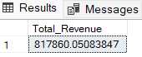

**2.Average Order Value:**

SELECT (SUM(total_price)/COUNT(DISTINCT order_id)) AS Avg_Ord_Value from pizza_sales;

**OUTPUT:**

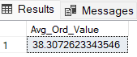

**3.Total Pizzas Sold:**

SELECT SUM(quantity) AS Total_Pizza_Sold from pizza_sales;

**OUTPUT:**

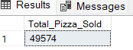

**4.Total Orders:**

SELECT COUNT(DISTINCT order_id) AS Total_Orders from pizza_sales;

**OUTPUT:**

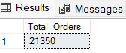

**5.Average Pizzas per Order:**

SELECT CAST(CAST(SUM(quantity) AS DECIMAL(10, 2))/CAST(COUNT(DISTINCT order_id) AS DECIMAL(10, 2)) AS DECIMAL(10, 2)) AS Avg_Pizza_per_Order from pizza_sales;

**OUTPUT:**

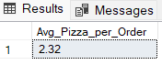

**B. Problem Statement- Charts Requirement**

**1.Daily Trend for Total Orders**

SELECT DATENAME(DW, order_date) AS Order_Day,

COUNT(DISTINCT order_id) AS Total_Orders

from pizza_sales

GROUP BY DATENAME(DW, order_date);

**OUTPUT:**

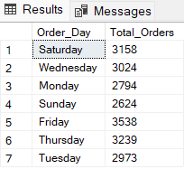

**2.Hourly Trend for Total Orders**

SELECT DATEPART(HOUR, order_time) AS Order_Hours, COUNT(DISTINCT order_id) AS Total_Orders

from pizza_sales

GROUP BY DATEPART(HOUR, order_time)

ORDER BY DATEPART(HOUR, order_time);

**OUTPUT:**

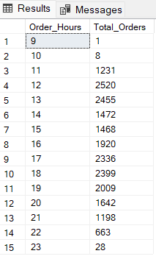

**3.Percentage of Sales by Pizza Category**

SELECT pizza_category,

CAST(SUM(total_price) AS DECIMAL(10, 2)) AS Total_Sales,

CAST((SUM(total_price) * 100/(SELECT SUM(total_price) from pizza_sales))AS DECIMAL(10, 2)) AS Perc_Pizza_Sales

from pizza_sales

GROUP BY pizza_category;

**OUTPUT:**

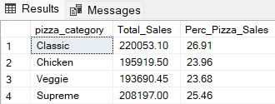

**4. Percent of Sales by Pizza Size**

SELECT pizza_size,

CAST(SUM(total_price) AS DECIMAL(10, 2)) AS Total_Sales,

CAST((SUM(total_price) * 100/(SELECT SUM(total_price) from pizza_sales))AS DECIMAL(10, 2)) AS Perc_Pizza_Sales

from pizza_sales

GROUP BY pizza_size

ORDER BY Perc_Pizza_Sales DESC;

**OUTPUT:**

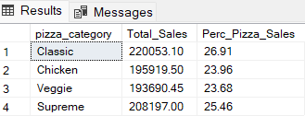

**5.Total Pizzas sold by Pizza Category**

SELECT pizza_category, SUM(quantity) AS Total_Pizza_Sold from pizza_sales

GROUP BY pizza_category

ORDER BY Total_Pizza_Sold DESC;

**OUTPUT:**

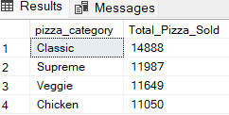

**6.Top 5 Best Sellers by Total Pizzas sold:**

SELECT TOP 5 pizza_name, SUM(quantity) AS Total_Pizza_Sold from pizza_sales

GROUP BY pizza_name

ORDER BY Total_Pizza_Sold DESC;

**OUTPUT:**

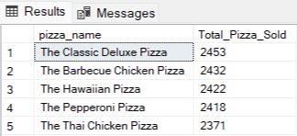

**7.Top 5 worst Sellers by Total Pizzas sold**

SELECT TOP 5 pizza_name, SUM(quantity) AS Total_Pizza_Sold from pizza_sales

GROUP BY pizza_name

ORDER BY Total_Pizza_Sold ASC;

**OUTPUT:**

